Aventus Software

🔹 Definition
# Source: ScreenShots Source: Provided by: [Persons Table -> ID Column: 1, Name_En Column: Motasem Essam] -> Tool: [Lightshot Program] -> From [Site: https://www.aventussoftware.com/] on [11/15/2025]
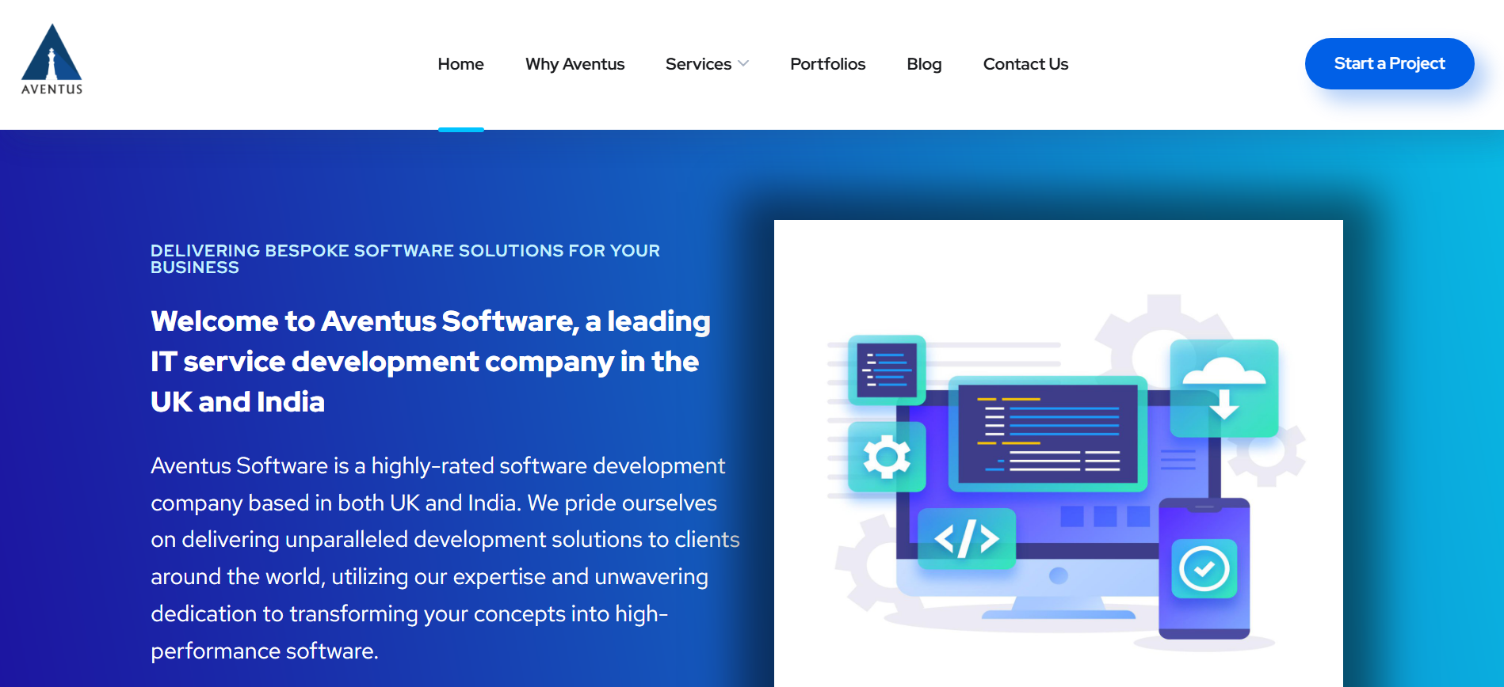
# Source: AI Source: Provided by: [Data Path: Persons Table -> ID Column: 1, Name_En Column: Motasem Essam] -> From: [ChatGPT] on [11/15/2025]
Aventus Software (https://www.aventussoftware.com/) is, based on their official site and other public sources:
🖥️💡 What the Site Is / Does
- Aventus Software is a software development company with offices in the UK and India. (Aventus Software)
- They build custom software, web applications, mobile apps, and cloud-based solutions. (Aventus Software)
- Other services include: UI/UX design, quality testing, staff augmentation, and game development. (Aventus Software)
- They use a wide range of technologies: React, Angular, Python, .NET, AWS, mobile (iOS/Android), and more. (Aventus Software)

🎯 Purpose
# Source: AI Source: Provided by: [Data Path: Persons Table -> ID Column: 1, Name_En Column: Motasem Essam] -> From: [ChatGPT] on [11/15/2025]
- To help businesses transform digitally by delivering tailored, high-performance software solutions. (Aventus Software)
- They offer flexible engagement models: onshore, offshore, and hybrid teams. (Aventus Software)
- Their working models include fixed-price projects, dedicated teams, and agile development to meet different business needs. (Aventus Software)

🛡️ Safety & Legality
# Source: AI Source: Provided by: [Data Path: Persons Table -> ID Column: 1, Name_En Column: Motasem Essam] -> From: [ChatGPT] on [11/15/2025]
- This is a legitimate, legal business operating in the UK and India. (EU-Startups)
- Contact and office addresses are publicly listed. (Aventus Software)
- No obvious red flags from their website; however, like all vendors, you should review contracts, references, and project history when hiring.

📌 Summary
# Source: AI Source: Provided by: [Data Path: Persons Table -> ID Column: 1, Name_En Column: Motasem Essam] -> From: [ChatGPT] on [11/15/2025]
Aventus Software is a professional IT services company that specializes in custom software development, cloud services, mobile/web apps, and testing. They serve global clients and offer flexible delivery models to suit different business scales and needs. Their website is a legitimate business portal, not a piracy or “free software” site.

